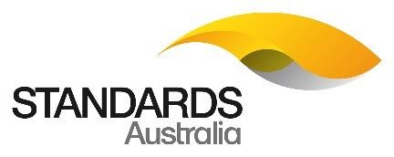

Proposal Form –
Standards Development Projects

Version:
Issued: 3 March 2022

Please click here for guidance on the proposal submission process.
Proposal title | Multi-building developments
Your name | Stephen Jennison
Preferred contact number | 07 5433 2368
Email address | Stephen.jennison@moretonbay.qld.gov.au
Name of employer | Moreton Bay Regional Council
Job title or position | Team Leader Plumbing Services
Postal address | P.O Box 159
Suburb | Caboolture
State | QLD
Postal code | 4510
Web address

If you are submitting on behalf of an organisation that is different than your current employer, please fill out the information below.
Nominating organisation
Primary contact name
Primary contact position
Primary contact email
Primary contact phone

Section 1: Scope

1A: Provide details of the proposed documents
# | Title  (e.g. Masonry cement) | Project type (e.g. revision,  amendment¹ or new²) | Designation  (e.g. AS 1316:2003)³ | Product type  (e.g. AS, AS Int, SA TS, etc...) 4
1 | Plumbing and Drainage Part 2 Sanitary plumbing and drainage | Amendment/ clarification | AS/NZS 3500.2:2021  Section 14 | AS/NZS
- An amendment is usually only possible for small changes to recently created documents. See Section 4 of Standardisation Guide SG-003: Standards and Other Publications for more details.
- If you are proposing to create a new document, please provide a suggested Title.
- Use the SAI Global website to obtain the full designation and name of existing documents.
- Standards Australia mainly develops Australian Standards (AS) but it also develops the following Product types: Australian
Interim Standard (AS Int), Australian Technical Specification (SA TS), Australian Technical Report (SA TR), Handbook (SA HB), Miscellaneous Publication (SA MP), Supplement (Normative), Supplement (Informative), Australian Standard Certified Reference Material (ASCRM). For guidance, see Standardisation Guide SG-003: Standards and Other Publications.
1B: Write a clear and concise statement of the nature of the issue to be addressed by your proposal. Describe who is affected e.g. businesses, community organisations or individuals affected by the problem. What are the consequences of no action?
AS/NZS 3500.2:2021 Section 14 Multi-unit developments.

Section 14 is very confusing and seems to contradict itself.

Glossary of Terms Part 0 AS/NZS3500.0:2021 3S.53; shall indicates that a statement is mandatory.

Section 14 Multi-unit developments
The scope of section
This Section specifies minimum requirements for the main lines of a sanitary drain located in a multi-unit development of three or more residential buildings.

NOTE: Where two or more Class 1 dwellings are located under the same roof, each individual dwelling is considered to be an individual building.

Clause 14.2.1 states, provisions SHALL be made for an inspection shaft, overflow relief gully and upstream vent, as specified in 14.2.3.

Clause 14.2.3, clause 14.2.3(b) only mention addition overflow relief from sewerage surcharge (not addition overflow relief gullies)

Therefore; as each individual dwelling is considered to be an individual building provisions SHALL be made for an inspection shaft, overflow relief gully and upstream vent.

Delete: In a multi-residential development, provision shall be made for an inspection shaft, an overflow relief gully and an open upstream vent, as specified in Clause 14.2.3, at each individual residential building, and
Clause 14.2.3(b) as this only relates to additional overflow relief from sewerage surcharge.

Insert: In a multi-residential development, provision shall be made for an inspection shaft, an overflow relief gully and an open upstream vent at each individual residential building.

14.3.2(b) an overflow relief gully in accordance with Clause 4.6.6

The below information highlights some of the issues within this section:

14.1 SCOPE of SECTION
This Section specifies minimum requirements for the main lines of a sanitary drain located in a multi-unit development of three or more residential buildings.

NOTE: Where two or more Class 1 dwellings are located under the same roof, each individual dwelling is considered to be an individual building.
14.2 METHODS OF DESIGN
14.2.1
In a multi-residential development, provision shall be made for an inspection shaft, an overflow relief gully and an open upstream vent, as specified in Clause 14.2.3, at each individual residential building.

14.2.3 Inspection shafts and overflow relief gullies and open upstream vents at each individual residential building.
In multi-unit developments, provisions shall be made at each individual residential building for the following:
- An inspection shaft in accordance with Clause 4.4.2, immediately upstream of the junction with the main line of the sanitary drain.
- Additional overflow flow relief from sewerage surcharge.
- An open upstream vent.
NOTE: Provided protection against sewage overflow has been made as specified in Clause 4.6.6, and any additional gully may have a lesser vertical separation than that specified in Clause 4.6.6.

The note is an informative section only, but the note highlights how to meet compliance of an overflow relief gully (ORG) (Clause 4.6.6).

4.6.6 Overflow relief gullies
4.6.6.1 General
At least one overflow relief gully shall be installed in the drain, except as provided in clause 4.6.6.2

The BPAA view is that the note 14.1 informative part is each individual dwelling is considered to be an individual building; therefore, each individual residential building requires a complying ORG as per 14.2.1 or install a reflux valve as per clause 4.5.2, and 14.2.3(b) only relates to additional overflow relief from sewerage surcharge.

Evidence of a problem
There has been a number of questions raised from plumbers, plumbing inspectors and hydraulic consultants as a result of the drafting of AS/NZS 3500.2 section 14 which has promoted a clarification from the WS-014 committee. Anecdotal evidence from QLD plumbing inspectors has indicated that this confusion has sometimes resulted in non-compliant installations that do not offer the appropriate level of protection from sewage surcharge. The non-compliant installations generally do not meet the Performance Requirements of the NCC in providing adequate access for inspection and maintenance as well as appropriate level of protection from surcharge events (refer to Exhibit 1 and 2).

Majority of these class 1 multi-unit developments have individual owners and may be their privately owned resident or tenanted.

As building designs and developments are moving to create a denser building environment, this type of construction relies on the prevention of sewage from entering the dwelling.

It is recommended that the WS-014 committee investigate the minor amendment to elucidate this issue raised by industry.

Example of a typical multi-residential development of 26 individually owned units with a single sewerage connection point located at the closest location to the distributors retailer’s sewerage connection point and a single ORG at the connection point.

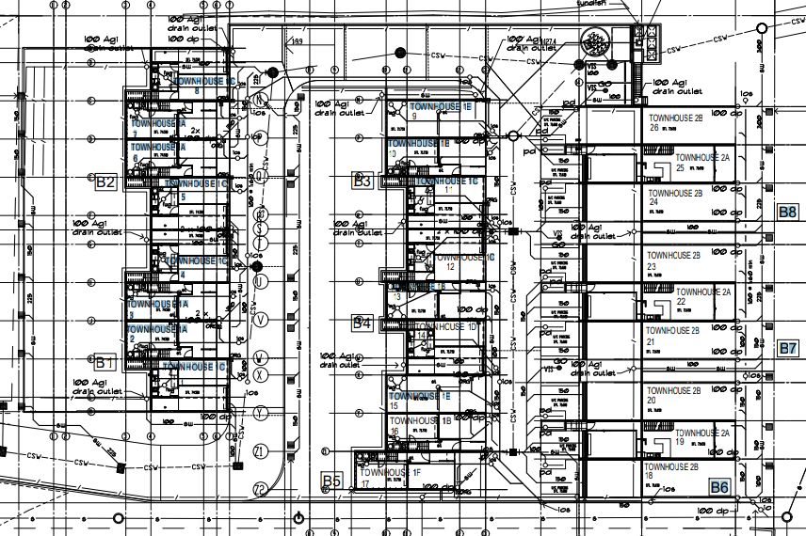

Extract-single sewerage connection point. Extract- single overflow relief gully installed to accommodate the
other 25 units

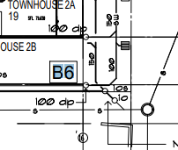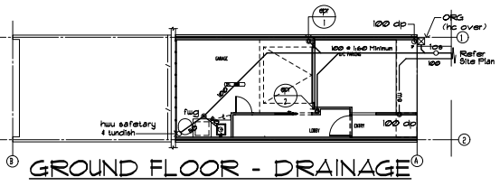

Risk: The installation of a single overflow relief gully installation, all individually owned units upstream of the ORG surcharge point located a unit 18 (refer to Extract 1) are unprotected, the ORG is installed approximately 10 meters lower than units 1 to 8 (refer to Extract 3), therefore any blockage upstream of the ORG have the multi-unit development other than unit 18 in contravention to the Plumbing Code of Australia part C2; C2O1 (a), C2F1, C2P5.
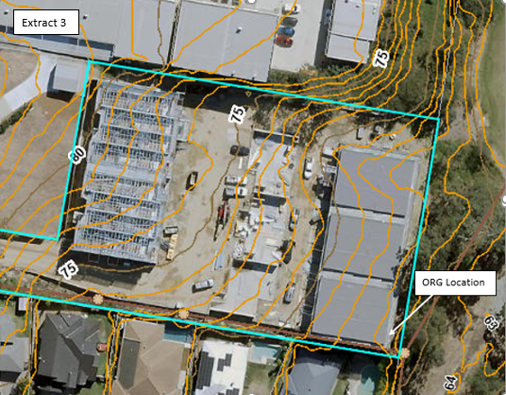

Exhibit 1 and 2 show a worst-case scenario of no overflow relief gully installed, the sewage is surcharging from the ground floor shower waste and floor waste. This surcharge flooded the complete ground floor rooms including bedrooms, hallway, office and laundry.

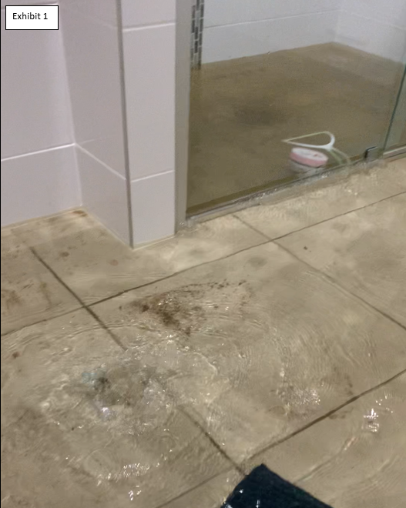
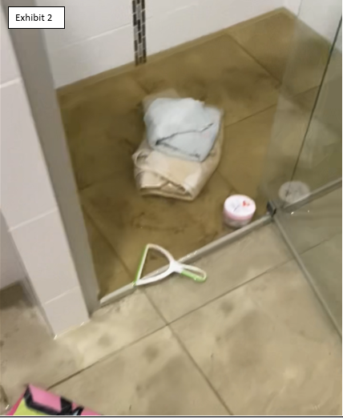

1C: Write a clear and concise proposed scope that will outline how to address the identified issue(s).
Unless this is a proposal for a new document, this should not be a scope of the document, but a scope of the work which you propose to undertake.
Include what is going to be changed from the status quo and summarise the specific intent of the change. If you wish to include proposed revisions as tracked changes in the standard, or an outline of a new standard, please summarise the scope and note the attachment here, and include the document as an appendix to this form.
There seems to be one primary task recommended by this proposal, the amendment of Clauses 14.2.1 and 14.2.3.

14.2.1 General
In a multi-residential development, provision shall be made for an inspection shaft, an overflow relief gully and an open upstream vent at each individual residential building located on a ground floor.

14.2.3 Inspection shafts and overflow relief gullies and open upstream vents at each individual residential building
In multi-unit developments, provisions shall be made at each individual residential building for the following:
- An inspection shaft in accordance with Clause 4.4.2, immediately upstream of the junction with the main line of the sanitary drain.
- An overflow relief gully in accordance with Clause 4.6.6
- An open upstream vent.

1D: Are you proposing an adoption of an International Standard (i.e. ISO or IEC)?

If so answer the following:⁵
Is it a Modified or Identical Adoption?
Note: if Identical use the Proposal Form –
Identical Adoption
What is the designation? e.g. ISO 10303.212-2004
- Use the SAI Global website to obtain the full designation and name of existing documents.
1E: Is the existing document referenced in Australian State, Territory or Commonwealth legislation or regulatory framework?
For joint documents, also consider New Zealand legislation.⁶
Yes (List all legislation or regulation that refer to the existing document.7)  Note: For National Construction Code  (NCC) and WaterMark proposals, the  Australian Building Codes Board (ABCB) needs to be consulted prior to submission. | Primary referenced document in the Plumbing Code of Australia and New Zealand Building Code.
No (Go to 1F)
- To search for standards in Australasian legislation, use our search function here.
- Use the full formal designation for the relevant legislation, e.g. Explosives Regulation 2013 (NSW). If more than four items of legislation are affected, provide a list as an attachment to this proposal form.
Note: All relevant regulatory authorities must be consulted in the stakeholder consultation.

1F: Is there an ISO/IEC document that also covers the issues in question?
Yes (Go to 1G)
No (Go to 1G) | No

1G: Will the proposed document include any conformity assessment requirements?
Yes
No | No

Section 2: Net benefit

2A: What will be the impact of the proposed project in the below categories? Explain this in terms of a positive or negative impact on the following “Net Benefit” criteria.
Public health and safety (max 200 words)
Non-compliant installation of overflow relief gullies can create overflow of sewerage into a building at the next lowest fixture point being a shower or floor waste. These overflow events are common and are caused by surcharges from Network Utility Operator infrastructure and blockages within the property, with multi-unit or multiple buildings were fixture use cannot be isolated.

Sewage surcharge can cause significant health issues and costs to the occupants and owners of the buildings.
It is considered that there will be a positive impact as public health and safety will be enhanced by this proposal which will help ensure that the minimum requirements for overflow relief gullies to be installed in multi-residential developments and the Plumbing Code of Australia requirements are met.

There will be a benefit by amending Section 14 to clarify overflow relief gully requirements as improvements in the clarity of the provisions will reduce the risk of non-compliance and the health issues which may occur in a sewage surcharge event.
Social and community impact (max 200 words)
It is considered that there will be no social or community impacts as a result of the proposed change.
Environmental impact (max 200 words)
It is considered that there will be a positive environmental impact. There will be a reduced likelihood of sewerage surcharge and damage which may be caused by sewer blockages as a result of improved plumbing practitioner compliance with AS/NZS 3500.2 and the Plumbing Code of Australia.

Sewage overflow can create significant environmental issues if allowed to escape into waterways and other sensitive areas. Whilst this proposal is not expected to lessen the number of occurrences, it will ensure that when these events occur that sewerage is discharged in the appropriate location (outside of a building).
Competition (max 200 words)
It is considered that there will be a positive impact on competition, as it will create level playing field through consistent interpretations of the requirements and reduce non-compliance with the installation of overflow relief gullies in provisions with section 14 AS/NZS 3500.2 and the Plumbing Code of Australia.

Where non-compliance occurs thought the incorrect interpretation of the section, there is one building or unit that is significantly disadvantaged and will be victim of the sewerage discharge within their building/unit being the lowest sewage opening in a sanitary drainage system. This will have a significant economic impact on the owners.
Economic impact (max 200 words)
It is considered that there will be a positive impact as it will reduce the likelihood of confusion and increase compliance with section 14 AS/NZS 3500.2 and the Plumbing Code of Australia.

Where non-compliance occurs thought the incorrect interpretation of the section, there is one building or unit that is significantly disadvantaged and will be victim of the sewage discharge within their building/unit being the lowest sewage opening in a sanitary drainage system. This will have a significant economic impact on the owners.

Attachment 1 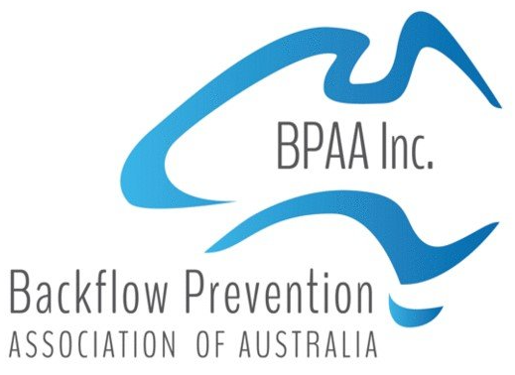
16 June 2022
WS-014 Amendment Proposal for AS/NZS3500.2 section 14
Dear WS-014
I am writing on behalf of the Backflow Prevention Association of Australia (BPAA) and a Committee member of the WS-014 group for clarification and/ or amendment to AS/NZS3500.2 section 14 Multi-unit developments.
Unfortunately, section 14 is very confusing and seems to contradict itself. Clause 14.2.1 states, provisions SHALL be made for an inspection shaft, overflow relief gully and upstream vent, as specified in 14.2.3. Clause 14.2.3 only mention addition overflow relief from sewerage surcharge.
Clause 14.2.1 states, provisions SHALL be made for an inspection shaft, overflow relief gully and upstream vent, as specified in 14.2.3. Clause 14.2.3 only mentions addition overflow relief from sewerage surcharge and not addition overflow relief gullies 14.2.3(b).
14.1 SCOPE OR SECTION
This Section specifies minimum requirements for the main lines of a sanitary drain located in a multi-unit development of three or more residential buildings.
NOTE: Where two or more Class 1 dwellings are located under the same roof, each individual dwelling is considered to be an individual building.
14.2 METHODS OF DESIGN
14.2.1
In a multi-residential development, provision shall be made for an inspection shaft, an overflow relief gully and an open upstream vent, as specified in Clause 14.2.3, at each individual residential building.
14.2.3 Inspection shafts and overflow relief gullies and open upstream vents at each individual residential building.
In multi-unit developments, provisions shall be made at each individual residential building for the following:
- An inspection shaft in accordance with Clause 4.4.2, immediately upstream of the junction with the main line of the sanitary drain.
- Additional overflow flow relief from sewerage surcharge.
- An open upstream vent.
NOTE: Provided protection against sewage overflow has been made as specified in Clause 4.6.6, and any additional gully may have a lesser vertical separation than that specified in Clause 4.6.6.

The note is an informative note, but the note highlights how to meet compliance of an ORG (Clause 4.6.6) and the second section to Clause 4.6.6 has a comer which then relates to any additional gully installed.
The work shall is defined as MUST.
My view is the note 14.1 informative is that they are each individual buildings; therefore each individual residential building requires a complying ORG as per 14.2.1 or install a reflux valve as per clause 4.5.2.

Yours Sincerely
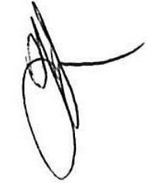
Stephen Jennison
Senior Plumbing Inspector
Development Services
Planning and Economic Development
Moreton Bay Regional Council
PO Box 159, Caboolture Qld 4510
P: (07) 5433 2368
M: 0417 732 342

See Standardisation Guide SG-006: Rules for the structure and drafting of Australian Standards. Note that conformity assessment requirements are rarely permitted in a standard. If you selected “yes,” please discuss with the relevant National Sector Manager prior to submission.

